Assignment 4

Normal Typing Test:

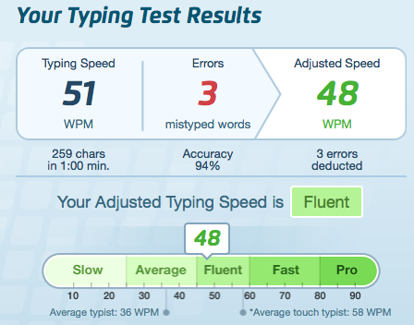

Javascript (Coding) Typing Test:

